PUBLIC HEALTH CLINIC RECORD SYSTEM USING MYSQL
1. Introduction
The Public Health Clinic Record System is designed to improve healthcare record management in government-run community health clinics in Sierra Leone. Traditionally, patient information, clinic visits, diagnoses, and treatments are recorded manually, resulting in inefficiencies, data loss, and difficulty in retrieving medical histories.
This project supports Sustainable Development Goal (SDG) 3: Good Health and Well-being by introducing a structured digital database system that improves healthcare service delivery, patient record management, and decision-making.
The system was designed using database modeling techniques and implemented using MySQL through XAMPP and phpMyAdmin.

2. Relevance to SDGs and Sierra Leone Problem
Sustainable Development Goal (SDG 3): Good Health and Well-being
The project addresses healthcare challenges faced by many clinics in Sierra Leone, including:
- Manual record keeping
- Difficulty tracking patient history
- Loss or damage of paper records
- Delays in retrieving patient information
- Poor reporting and monitoring of clinic activities
The proposed database system provides:
- Efficient storage of patient records
- Improved appointment management
- Better diagnosis and treatment tracking
- Improved healthcare reporting
- Faster access to patient information

3. Refined Physical Data Model
The final Physical Data Model contains six tables:
- Patient
- HealthWorker
- Appointment
- ClinicVisit
- Diagnosis
- Treatment
Relationships
- One Patient can have many Appointments.
- One Patient can have many Clinic Visits.
- One Health Worker can attend many Clinic Visits.
- One Clinic Visit can generate many Diagnoses.
- One Diagnosis can have many Treatments.
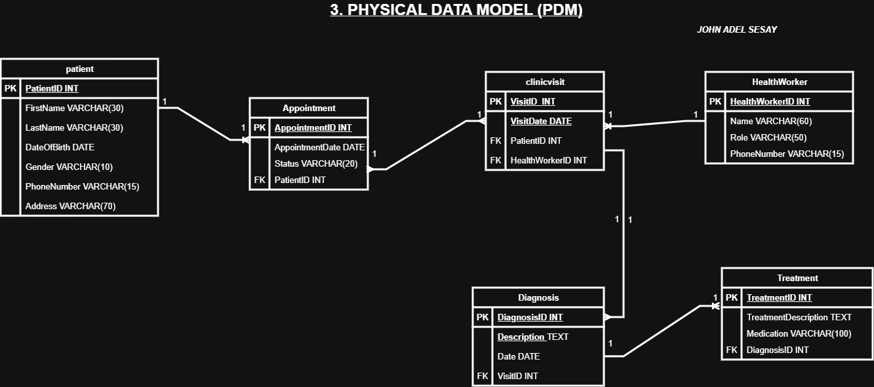

4. Design Decisions
Data Types
INT
- Used for primary keys because they are efficient and unique.
VARCHAR
- Used for names, phone numbers, and addresses because these fields contain variable-length text.
DATE
- Used for appointments, visits, and diagnoses because date tracking is important in healthcare systems.
TEXT
- Used for diagnosis descriptions and treatment descriptions because they may contain lengthy medical notes.
Relationships
Foreign keys were implemented to maintain referential integrity and ensure data consistency between related tables.

5. Database Implementation
Database Creation
Database Name:
PublicHealthClinic
Tables Created
- Patient
- HealthWorker
- Appointment
- ClinicVisit
- Diagnosis
- Treatment
Primary keys and foreign keys were implemented to maintain relationships between tables.

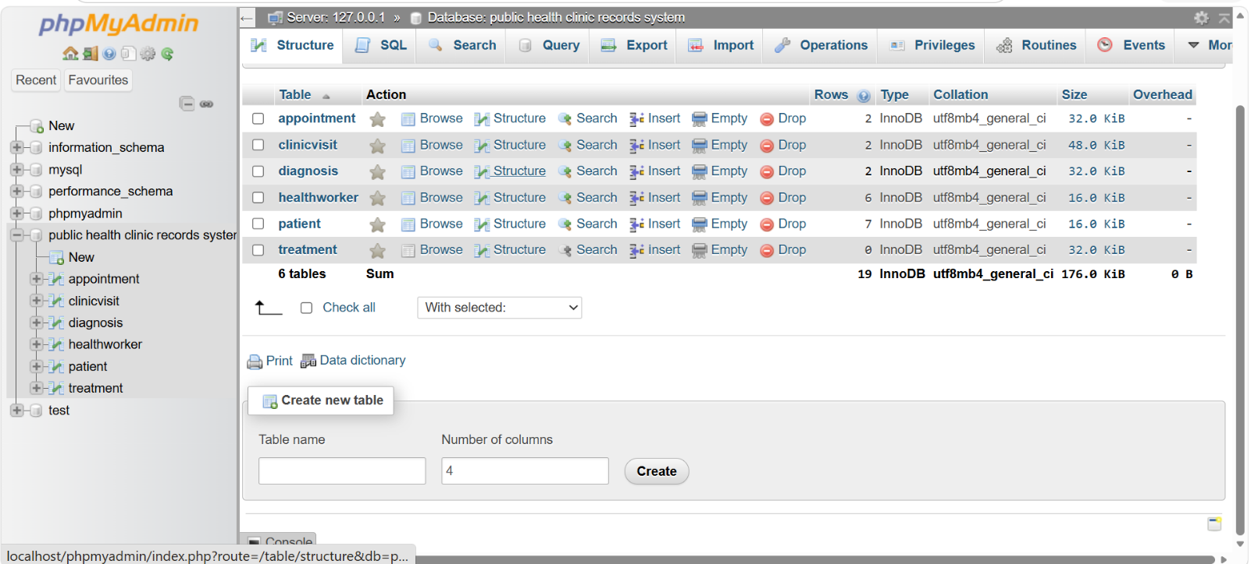
Below are the Screenshot of Database Creation
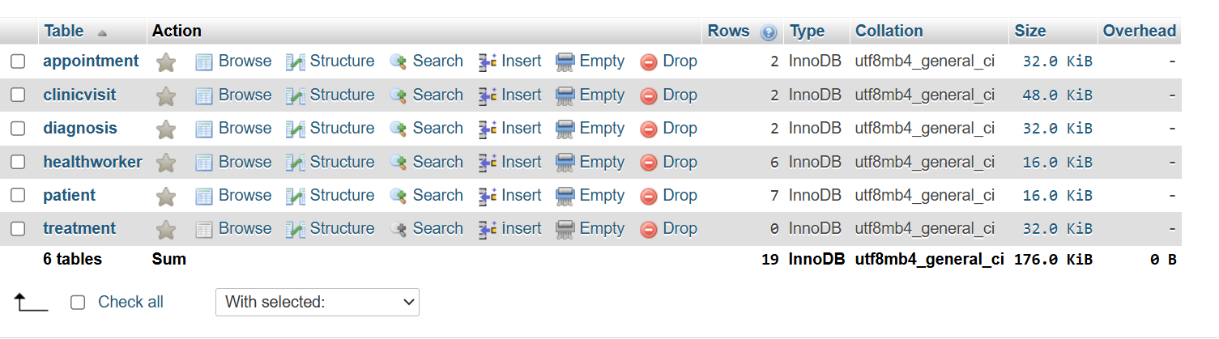

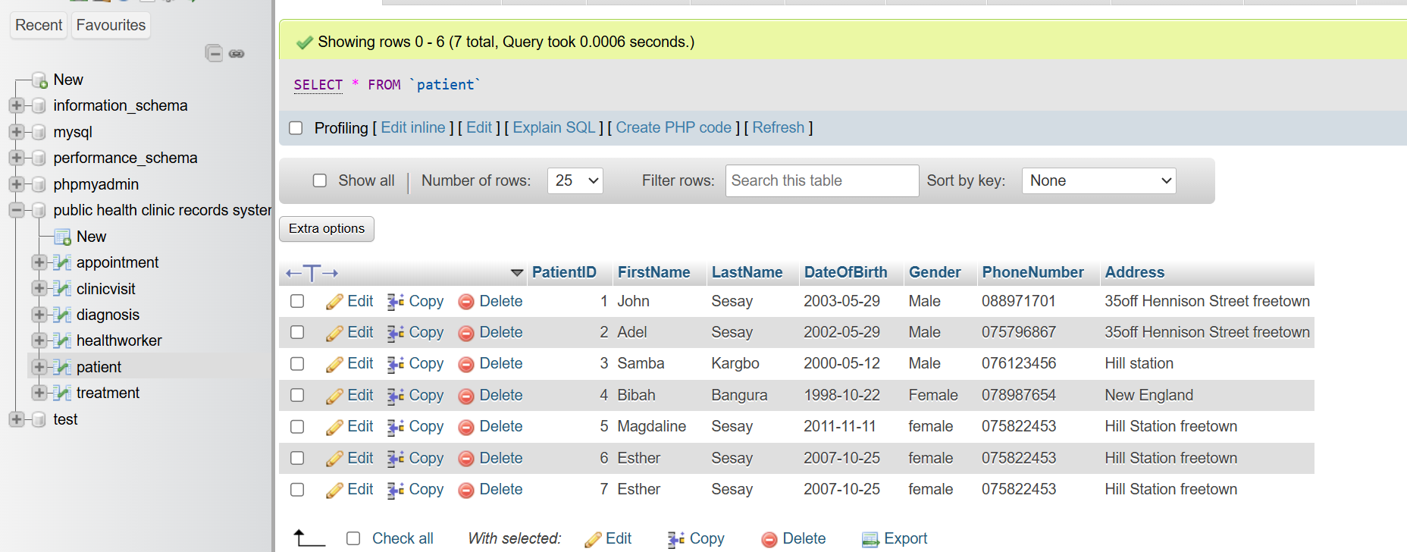
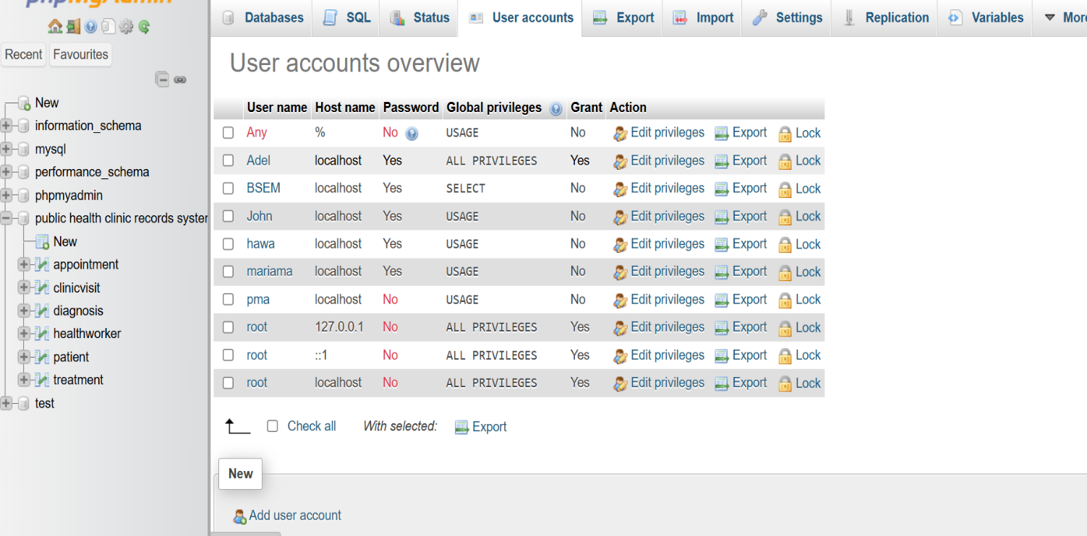

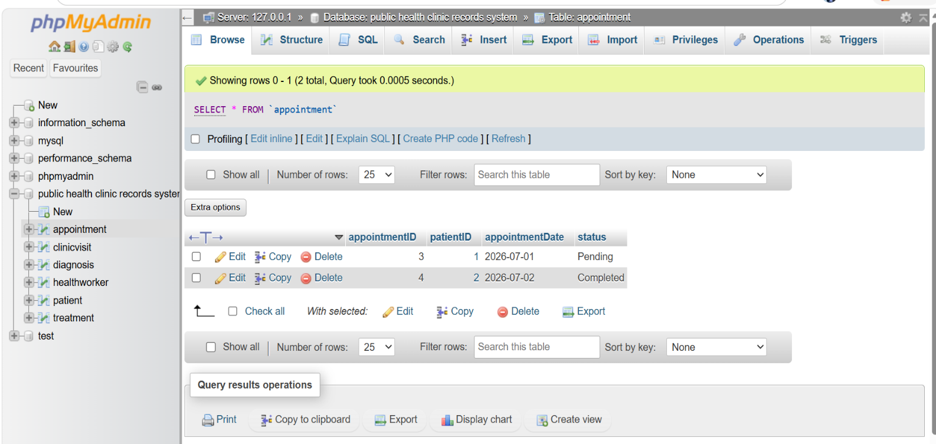

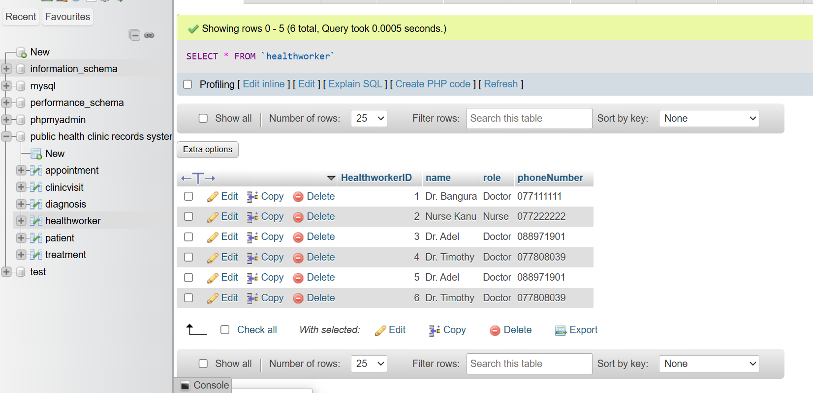

Importance of Database Security
Database security protects patient information from unauthorized access, modification, and deletion.
The system uses role-based access control to ensure users can only perform tasks relevant to their responsibilities.
This improves:
- Confidentiality
- Integrity
- Availability
and follows the Principle of Least Privilege.


8. Conclusion
The Public Health Clinic Record System successfully demonstrates the practical implementation of database design principles using MySQL.
The project provides a reliable and secure method of managing patient information, appointments, diagnoses, and treatments. It contributes to SDG 3 by supporting improved healthcare service delivery in Sierra Leone.
The project also demonstrates skills in database design, implementation, data manipulation, querying, and security management.

